**PROPOSAL REPORT**

**ON**

**BOREWELL RESCUE ROBOT**

**TEAM DETAILS**

**Praveen S BE-Material Science II Year**

**Ashiq Rahman BE-Mechanical II Year**

**Swarubini PJ BE-Biomedical III Year**

**OBJECTIVE:**

When a child has fallen into a bore well , it is difficult for normal rescue operation to safeguard the child. The use of advanced technology and more precise controls can play a vital role in the rescue operation of the child. The main aim of this robot is to rescue the child from the bore well hole with minimal amount of injuries. Our bot is designed for minimal hole diameter and there is no restriction with the depth it can reach. The necessary safety measures for rescuing the child will be implemented during the procedure. Our robot is capable of moving inside the hole and it performs according to the users command. This arrangement ensures that the child does not slip further deep during the rescue operation. This entire robot model is totally controlled manually by human and suitable camera and sensors are also placed to watch and sense the process.

**INTRODUCTION:**

In our country and mostly in rural areas due to the scarcity of water more bore well hole are dug. However in villages and farming area there is a constant need of water. So the water from rivers and lakes are not suffice every time. People's need for water can also be achieved by groundwater. So in our country there are more bore well dug. Not every bore well gives a good way of taking water, some hole should be dug more deeply into the ground to get water. However many bore wells do not yield and are abandoned. Vegetation take over that place and these bore wells are forgotten.

These are done for the purpose of getting water but some children are unaware and play around these area and they don't recognize these as their death trap. Unfortunately 92% of the victim age is below 10. As the statistics suggests , from 2006 more than 30 deaths have occurred in our country. The bore well diameter is too small for adult and children could easily fell down. The darkness and lack of oxygen in the bore well takes the life of the child slowly. Some bore wells are 300 ft deep(or more). The child might not always fall to the bottom but get stuck in the mud in between. Depends upon the soil condition, the slippage of the child and could maximum collapse if its a marshy condition. These condition are also required to safeguard the child safely. The rescue operation must be quite precise and carefully done to rescue the child.

There are plenty of bore well accidents in our country and recently in Tamilnadu. We wouldn’t have ever forgotten about the tragic Sujith Wilson's death occurred in a village near Trichy after playing near an abandoned bore well and he accidently fell down in it. It happened on 25 October 2019 at around 5.45 pm. The rescue operation commenced on a full swing for 80 hours. But unfortunately , Sujith died after a hard struggle in that deathly atmosphere. Around 2:00 am 30 October 2019 officials confirmed the death of the boy.

Rescue operation can be carried out in many ways. Sometimes if the child is closer to the surface the rescuer gets in and pulls them out. However if the child has fell into greater depths, initially a camera is sent into the hole and check the condition of the child. The common idea is to dug a parallel hole away from the bore well hole and to send a rescuer in the parallel to rescue the child. But due to the geological issues this rescue plan often doesn't succeed. Even it is more difficult for the best technology to succeed ,because any disturbance to the hole can block the access point to safe the child.

**Literature Survey:**

A major problem faced by the human society was water scarcity which is analyzed by Bharathi and Suchitha. Due to drought and depletion of underground water, more bore wells are drilled on the surface of the earth. In many areas, the bore wells are drilled and left open without any proper covering. These bore wells became death pits and started taking many lives especially small children. Now a days falling of children in bore wells are increasing due to carelessness and playful activities of the children. The hole dug for the bore wells are deep around 800 feet. The maximum depth is in Bengaluru of about 1700 feet. In these cases, the rescue of child from such deepest bore well is quite challenging.

B. Bharathi et.all [1]describes the design of a robot for rescuing the child from bore well. This robot is capable of moving to the inside the bore well, according to the commands given to PC and also pick and place based on the arm design. This robot is operated through PC with the help of wireless Zigbee technology and wireless camera which gives both the audio and video signals on the TV monitor. The high power LED in the robot acts as a light source in the pipe since the light intensity is low. The main drawback is that the arm structure can’t give adequate security to the child while lifting.

John Jose Pattery [2] describes the facility that monitors the child in the borewell, supplies the oxygen and provides a supporting platform to lift up the child. The first motor placed at top turns a gear mechanism which in turn pushes 3 blocks arranged at 120 degree from each other towards the side of the bore well. The bottom shaft is turned by 130 degrees with the help of second motor, thus helping to locate the gap through which the lifting rod is adjusted by third motor. When the diameter is adjusted, the forth motor helps the lifting rod to screw its way through the gap towards the bottom of the child. Once lifting the rid reaches a safe position under, an air compressor is operated to pump air to the bladder attached to the end of lifting rod through an air tube that runs downwards inside the lifting rod. The bladder provides a safe seating to the child. Them the first motor is reversely operated so as to unclamp the system. Simultaneously it is lifted out of the well using a chain or rope.

Giridharan .M described about designing a robot consists of three engines to save a child on the drag well. The primary engine is used for movement which is up and down by using screw bar. Second engine is utilized for grabbing reason with the surface of lead screw arrangement. Another engine is used to rescue the child through rack and pinion arrangement. Based on the location of the child, the whole arrangement can be pivoted. Then the child is lifted from the bore well.

Arthika.S described about the mechanism of safeguarding child from the bore well. The temperature sensor is used to detect the temperature and similarly gas sensor is used to detect the gas spillage in the specific region. ARM compression and expansion method is used for roper up and down movement. The robotic arm is using relay operation for picking and placing the child. This method provides safeguarding activities in less time. The major drawback is lifting of child is very difficult by using gripping arm.

**Proposed Work:**

1. **Mechanical Aspect:**

The mechanics of the bot is actuated by 7 actuators. There are 3 major mechanisms in the bot to be noted. The main aim of the bot is not just just save the child to bring him back safe and sound. The actuators in the bot are controlled via switches on the operators side. There are different types of actuators involved here. Let's have a look at the actuators of the bot and controlling is done.

The 1st actuator (25 kg cm motor) controls the jack head assembly. Which is used for opening and closing the assembly. This provides stability to the structure.

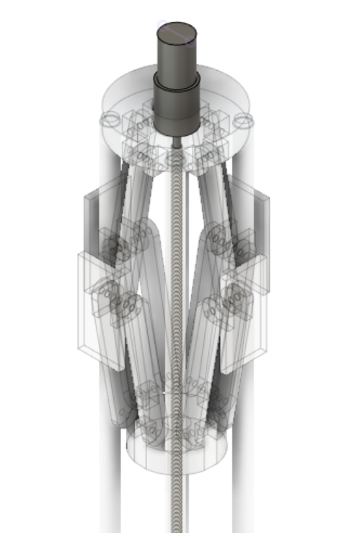

**Figure: Actuator 1**

The 2nd actuator (40kg cm motor) is used for rotating the bot. Here the actuator uses bevel gear on its shaft which is meshed with bevel gear on the main shaft, their axis of rotation is parallel to each other.

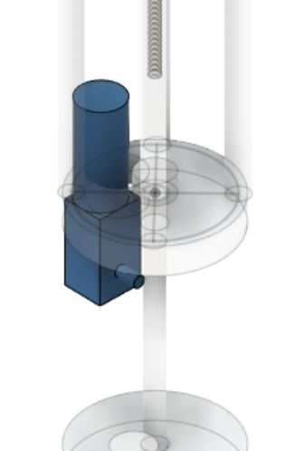

**Figure: Actuator 2**

The 3rd actuator(25 kg cm motor) is  used to control the vertical position of the cage structure. Here the motor shaft is attached to the worm gear which is screwed into the top plate. So upon rotation of motor the top plate can move along the length of the worm gear

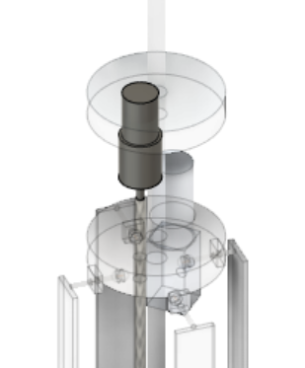

**Figure: Actuator 3**

The 4th actuator (40 kg cm motor) is used to expand or contract the cage structure.the mechanism use here is similar to that of the jack head assembly.

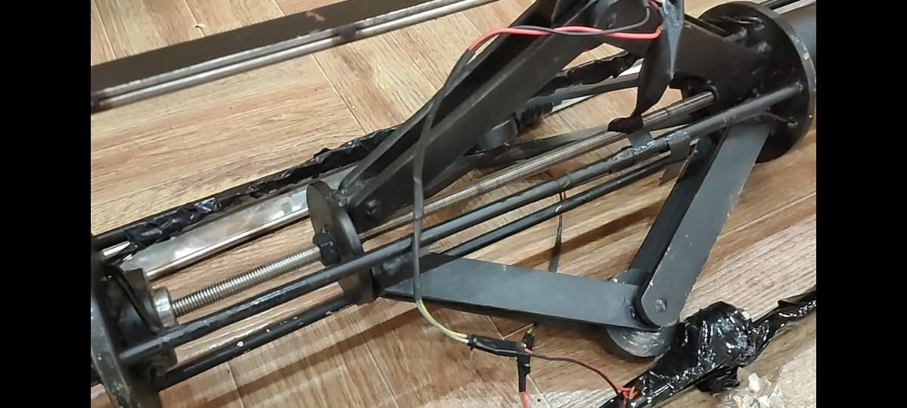

**Figure: Actuator 4**

The 5th actuator (25 kg cm motor) is used to increase or decrease the length of the bottom structure of the bot. It uses the worm gear mechanism to control it.

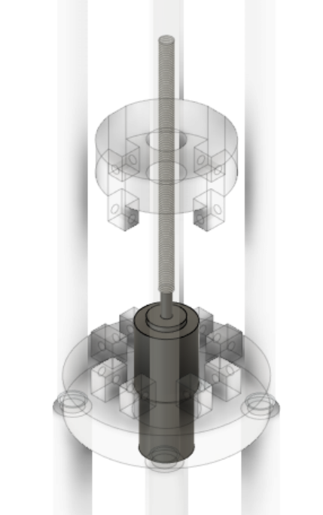

**Figure: Actuator 5**

The 6th actuator(25 kg cm motor) is used to close or open the end effector (grappers).

The motor is attached to the worm gear which is screwed into the bottom plate as shown. The bottom plate also has four hinges attached whose movement can control the arms of the gripper.

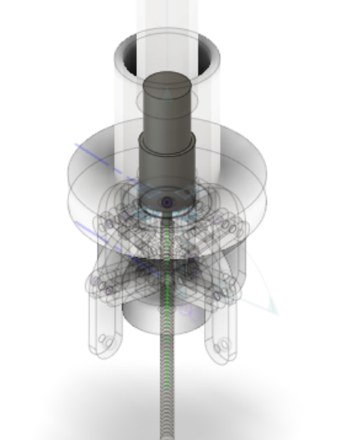

**Figure: Actuator 6**

The 7th actuator is used on the cage structure. This is to provide clearance for cage structure to enter into congested places and by providing vibrations up to 10Hz. The actuator used here are eccentric vibration motors

**Main Assemblies:**

1. **Jack Head Assembly**

This Assembly is what holds or supports the entire structure in place. This is where the first actuation that will take place once the bot reaches the required position.

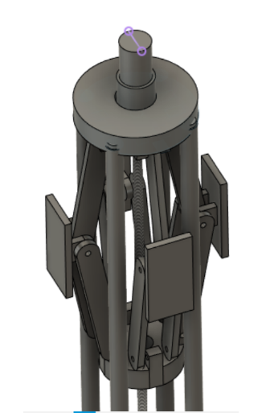

**Figure: Jack Head Assembly**

From the diagram it's evident that when the actuator is turned on, the lead screw attached to the actuator starts to rotate. Due to its one degree of freedom the leadscrew brings the base plate close to the top plate. Now this action would cause the hinge arms to move outwards  and eventually the side plates would be in contact with the walls of the borewell securing the bot in one place.

1. **Jaw mechanism**

The position of the child has to be in control, for the rescue operation to be successful. Considering this in mind the gripping mechanism is used to hold a part of the child(hand or head)  so that the further operations can take place smoothly.

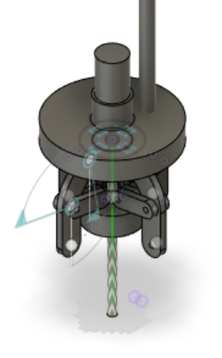

**Figure: Jaw Mechanism**

1. **Cage Structure:**

This structure is used to enclose the child and bring him safely. So once the child's position is noted and the cage structure expands to the maximum(diameter of the borewell) and is send down along the wall of the borewell eventually covering the child in the four directions and then the cage structure closes and holds the child firmly.

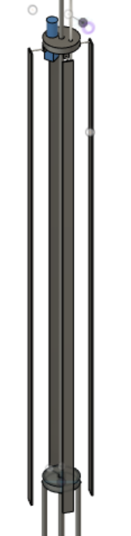

**Figure: Cage Structure**

After this the jack head loosens and the bot is lifted up.

1. **Electronic Aspect:**

Arduino is used for control of actuation of the bot. The is made to be wireless. The electronics involved in this project are:

1.Arduino

2.HC-12

3.Relay

4. Gas Sensor

5.Force Sensor

6. IR sensor

**Working procedure:**

* The user gives input to the transmitter of Arduino via switches.
* Arduino recognizes the command and sends it to the transmitter module.
* The transmitter module which has already established connection with the receiver module, sends the corresponding messages in the form of packets and the receiver receives them one by one and sends it to the receiver arduino.
* The arduino interprets the message and executes the command which is the turning on and off of the switch.
* There is also a closed feedback loop established.
* Here the sensors ( force sensor ) senses for any signal and if received it sends a message to the receiver arduino and overwrites the messages given to the receiver arduino from the transmitter and stops the process.
* Then a message is sent to the transmitter and the operator reacts accordingly.

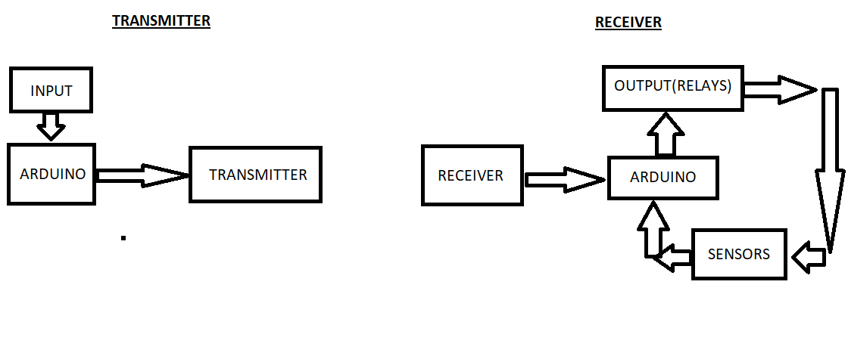  **Figure: Overall Block diagram of the electronics involved in the project.**

**Components Required:**

1. **Arduino:**

The Arduino Mega is an open source microcontroller board based on the **ATMEGA 2560.** A microcontroller is a computer present in a single integrated circuit which is dedicated to perform one task and execute one specific application. It contains memory, programmable input/output peripherals as well a processor. It has 54 digital input/output pins (of which 15 can be used as PWM outputs and 16 can be used as analog inputs), a 16 MHz resonator, a USB connection, a power jack, an in-circuit system programming (ICSP) header, and a reset button. It contains everything needed to support the microcontroller; simply connect it to a computer with a USB cable.

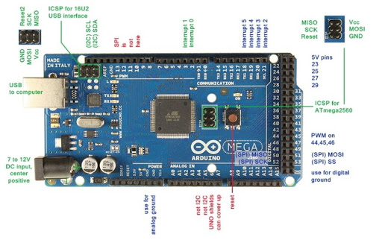

**Figure: Board Description**

1. **HC-12 Transceiver module:**

HC-12 wireless serial port communication module is a new-generation multichannel embedded wireless data transmission module. Its wireless working frequency band is 433.4-473.0MHz, multiple channels can be set, with the stepping of 400 KHz, and there are totally 100 channels. The maximum transmitting power of the module is 100mW (20dBm), the receiving sensitivity is -117dBm at a baud rate of 5,000bps in the air, and the communication distance is 1,000m in open space. The operating voltage of the module is from 3.2V to 5.5V and for more stable work a decoupling capacitor and external power supply.

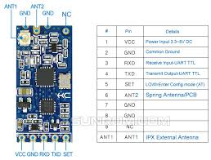

**Figure: HC 12 Transceiver Module**

1. **Relay Switch:**

A relay is a programmable electrical switch, which can be controlled by Arduino or any micro-controller. It is used to programmatically control on/off the devices, which use the high voltage and/or high current. It is a bridge between Arduino and high voltage devices.

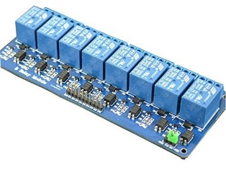

**Figure: Relay Switch**

1. **Gas Sensor:**

MQ2 is one of the commonly used gas sensors in MQ sensor series. It is a Metal Oxide Semiconductor (MOS) type Gas Sensor also known as Chemiresistors as the detection is based upon change of resistance of the sensing material when the Gas comes in contact with the material. Using a simple voltage divider network, concentrations of gas can be detected. MQ2 Gas sensor works on 5V DC and draws around 800mW. It can detect LPG, Smoke, Alcohol, Propane, Hydrogen, Methane and Carbon Monoxide concentrations anywhere from 200 to 10000ppm.

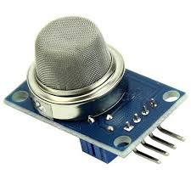

**Figure: Gas Sensor**

1. **Force sensor:**

An FSR is a variable resistor that varies in resistance as pressure is applied to the sensing area. It is made up of several thin flexible layers. The more it is pressed, the more resistive carbon elements touch the conductive traces and this reduces resistance. Most FSRs have either a circular or rectangular sensing area. Square FSRs are good for broad-area sensing, while small circular sensors can provide greater accuracy to the sensing field. The output voltage varies from 0 to 5V depending on the amount of force applied to the sensor.

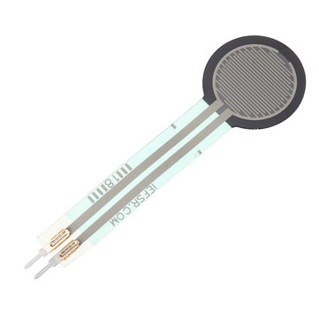

**Figure: Force Sensor**

1. **IR sensor:**

An infrared sensor is an electronic instrument that is used to sense certain characteristics of its surroundings. It does this by either emitting or detecting infrared radiation. Infrared sensors are also capable of measuring the heat being emitted by an object and detecting motion. Active infrared sensors both emit and detect infrared radiation. Active IR sensors have two parts: a light emitting diode (LED) and a receiver.

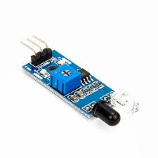

**Figure: IR Sensor**

1. **Motor:**

The 3 different types of motors used for in this project

1. DC Worm Gear Motor 12V High Torque Reduction Gear Box with Encoder Strong Self-Locking 6mm Output Shaft(100RPM)

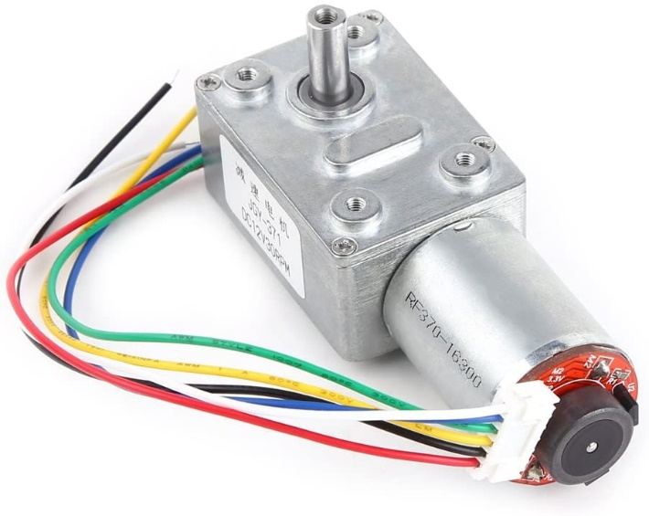

**Figure: DC Worm Gear Motor**

1. Planetary Gear Motor with base motor rpm - 18000, shaft RPM - 30 and 60, torque is - 70 kg cm

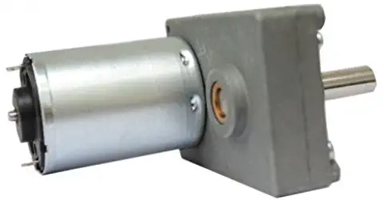

**Figure: Planetary Gear Motor**

1. UX cell 12V DC 5RPM Gear Motor High Torque Electric Micro Speed Reduction Geared Motor Eccentric Output Shaft

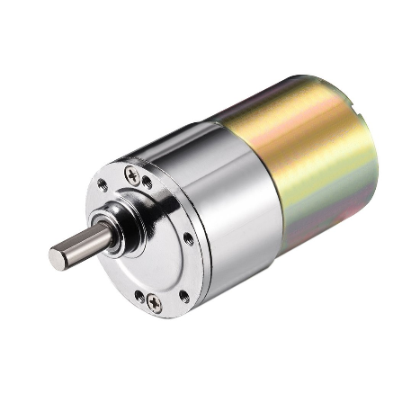

**Figure: UX cell Gear Motor**

1. **O2 Sensor:**

O2 sensor is an electronic device that measures the amount of [oxygen](https://en.wikipedia.org/wiki/Oxygen) (O2) in the gas or liquid being analysed. he original sensing element is made with a thimble-shaped [zirconia](https://en.wikipedia.org/wiki/Zirconia) [ceramic](https://en.wikipedia.org/wiki/Ceramic) coated on both the exhaust and reference sides with a thin layer of [platinum](https://en.wikipedia.org/wiki/Platinum) and comes in both heated and unheated forms.

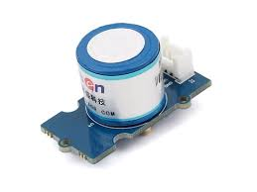

**Figure: O2 Sensor**

**Implementation:**

First the bot is set up and checked for connections. Once it has been made sure that everything works, the top part of the bot is attached to a nylon rope and  is sent down the bore well. Once the IR sensor( that acts as a distance sensor) senses the child as a feedback  the bot is stopped from  moving down. The jack head  of the bot secures the bot in place so that there won't be any oscillation while the whole operation takes place.

Next the bot is extended  to the required length. Using pressure sensors the bot’s gripper holds the child to prevent from further sliding down the borewell. And after all this is done the cage structure is  positioned properly and expanded to the diameter of the borewell and is sent down. It then securely encloses the whole body of the child in the cage assembly..

The amount of oxygen is measured the while and after the enclosing the child, oxygen is supplied to the child to prevent suffocation. Then the bot is released from its position and pulled up along with the child and the operation is completed.

**Work Plan:**

|  |  |  |
| --- | --- | --- |
| Month | Week | Work Schedule |
| June |  | Ground Work, Sourcing things |
| July | 1st Week | Purchase necessary sensors, actuators and motors |
|  | 2nd Week | Changes in Physical Model |
| August | 4th Week | Finishing the physical prototype with precision analysis |
| September | 1st Week | Programming the HC-12 module and Gas sensor |
|  | 3rd Week | Programming the Force sensor and IR Sensor |
| October | 2nd Week | Starting the development codes for microcontroller |
| November | 2nd Week | Error detection and Fine tuning the robot |
| December | 1st Week | Testing the prototype in any borewell hole |

**Expected Outcomes:**

1. The depth of the bot it can reach, can be increased by increasing the length of the rope.
2. It is more safer than the L-rod technique and other normal rescuing procedure.
3. Ensures that the child does not slip further deep into the borewell during the rescue operation.
4. Monitoring the Gas levels in the borewell which acts as a feedback enabling the user to increase/decrease the O2 level for the child to breathe in and remove the harmful gases out.

**Applications:**

* This robot is suitable for any depth and diameter.
* The robot has no restriction with the type of soil in which the borewell is dig.
* Safety is secured using this robot.
* Reduces the failure risk factors and promotes successful case rate.

**Conclusion:**

The Proposed system is predominantly intended to save the child with minimal amount of injuries. In the previous 15 years, bunches of lives had been lost by tumbling into the bore well since burrowing a pit adjacent to the drag well is time consuming process. By adapting this system, we can rescue the life of the child within a short span of time. The Robotic arm will pick the belt and fix it to the child appropriately. These robots are lifesaving machines. It can save many lives of the children, so it is very beneficial to use this robot.

**References:**

[1]. B. Bharathi, B. Suchitha Samuel “Design and construction of Rescue robot and pipeline Inspection using Zigbee”, International Journal.

[2]. John Jos Pottery ”robot for bore well rescue” Amal Jothi college of engineering vol 10, Jun 2009.

[3]. Nithin, G., Et Al. "Design And Simulation Of Bore Well Rescue Robot- Advanced." Arpn Journal Of Engineering And Applied Sciences 9.5 (2014): 3101-3104

[4]. Rajesh, Singuru, Gamini Suresh, And R. Chandra Mohan. "Design And Development Of Multi-Purpose Prosthetic Bore Well System-An Invincible Arm." Materials Today: Proceedings 4.8 (2017): 8983-8992.

[5]. Shah Vrunda, R., Chirag S. Dalal, And Rajeev Dubey. "Automate Machine For Rescue Operation For Child." International Journal Of Research In Engineering And Technology (2015).

**Financial Assistance:**

|  |  |  |  |
| --- | --- | --- | --- |
| Name of the Component | Price per piece (in Rs.) | Quantity | Price (in Rs) |
| Worm Gears | 2000 | 2 | 4000 |
| Spur Gears | 1000 | 1 | 1000 |
| Fabrication | 2000 |  | 2000 |
| Arduino Mega | 1000 | 1 | 1000 |
| IR sensor | 40 | 1 | 40 |
| HC 12 | 400 | 1 | 400 |
| Relay | 300 | 1 | 300 |
| Gas sensor | 250 | 1 | 250 |
| Force sensor | 600 | 2 | 1,200 |
| O2 sensor | 12,500 | 1 | 12,500 |

**Total: Rs. 22,690**